**FlyAway (An Airline Booking Portal).**

1. **Developing an Airline Booking Portal**

**This document contains sections for:**

* Project Description
* Core concepts used in project
* Flow of the Application.
* Project Users Stories : ( Agile and Scrum )
* Git Repositories
* How to run project
* Demonstrating the product capabilities, appearance, and user interactions.
* Conclusions

The code for this project is hosted at :

https://github.com/Atul105/Phase2-project

The project is developed by Atul Magar.

* 1. **Project Description:**

**Project objective:**

As a Full Stack Developer, design and develop an airline booking portal named as

Flyaway.

**Background of the problem statement:**

FlyAway is a ticket-booking portal that lets people book flights on their website.

**The administrator can:**

● A search form in the homepage to allow entry of travel details, like the date of travel, source, destination, and the number of persons.  
● Based on the travel details entered, it will show the available flights with their ticket prices.  
● Once a person selects a flight to book, they will be taken to a register page where they must fill in their personal details. In the next page, they are shown the flight details of the flight that they are booking, and the payment is done via a dummy payment gateway. On completion of the payment, they are shown a confirmation page with the details of the booking.

For the above features to work, there will be an admin backend with the following features:

● An admin login page where the admin can change the password after login, if he wishes  
● A master list of places for source and destination  
● A master list of airlines  
● A list of flights where each flight has a source, destination, airline, and ticket price

**The flow and features of the application:**

● Plan more than two sprints to complete the application  
● Document the flow of the application and prepare a flow chart   
● List the core concepts and algorithms being used to complete this application  
● Implement the appropriate concepts, such as exceptions, collections, and sorting techniques for source code optimization and increased performance

**You must use the following:**

● Eclipse/IntelliJ: An IDE to code for the application   
● Java: A programming language to develop the web pages, databases, and others  
● SQL: To create tables for admin, classes, students, and other specifics  
● Git: To connect and push files from the local system to GitHub   
● GitHub: To store the application code and track its versions   
● Scrum: An efficient agile framework to deliver the product incrementally   
● Search and Sort techniques: Data structures used for the project   
● Specification document: Any open-source document or Google Docs

**The following requirements should be met:**

● The source code should be pushed to your GitHub repository. You need to document the steps and write the algorithms in it.  
● The submission of your GitHub repository link is mandatory. In order to track your task, you need to share the link of the repository. You can add a section in your document.   
● Document the process step-by-step starting from sprint planning to the product release.   
● The application should not close, exit, or throw an exception if the user specifies an invalid input.  
● You need to submit the final specification document which will include:   
● Project and developer details   
● Sprints planned and the tasks achieved in them   
● Algorithms and flowcharts of the application   
● Core concepts used in the project   
● Links to the GitHub repository to verify the project completion

* 1. **Core concepts used in the project:**

-> Used Java Language in Eclipse IDE.

-> File Handling

-> Collections framework

-> Sorting

-> Flow Control

-> Recursion

-> Exception Handling

-> Streams API

->MYSQL-workbench

1. 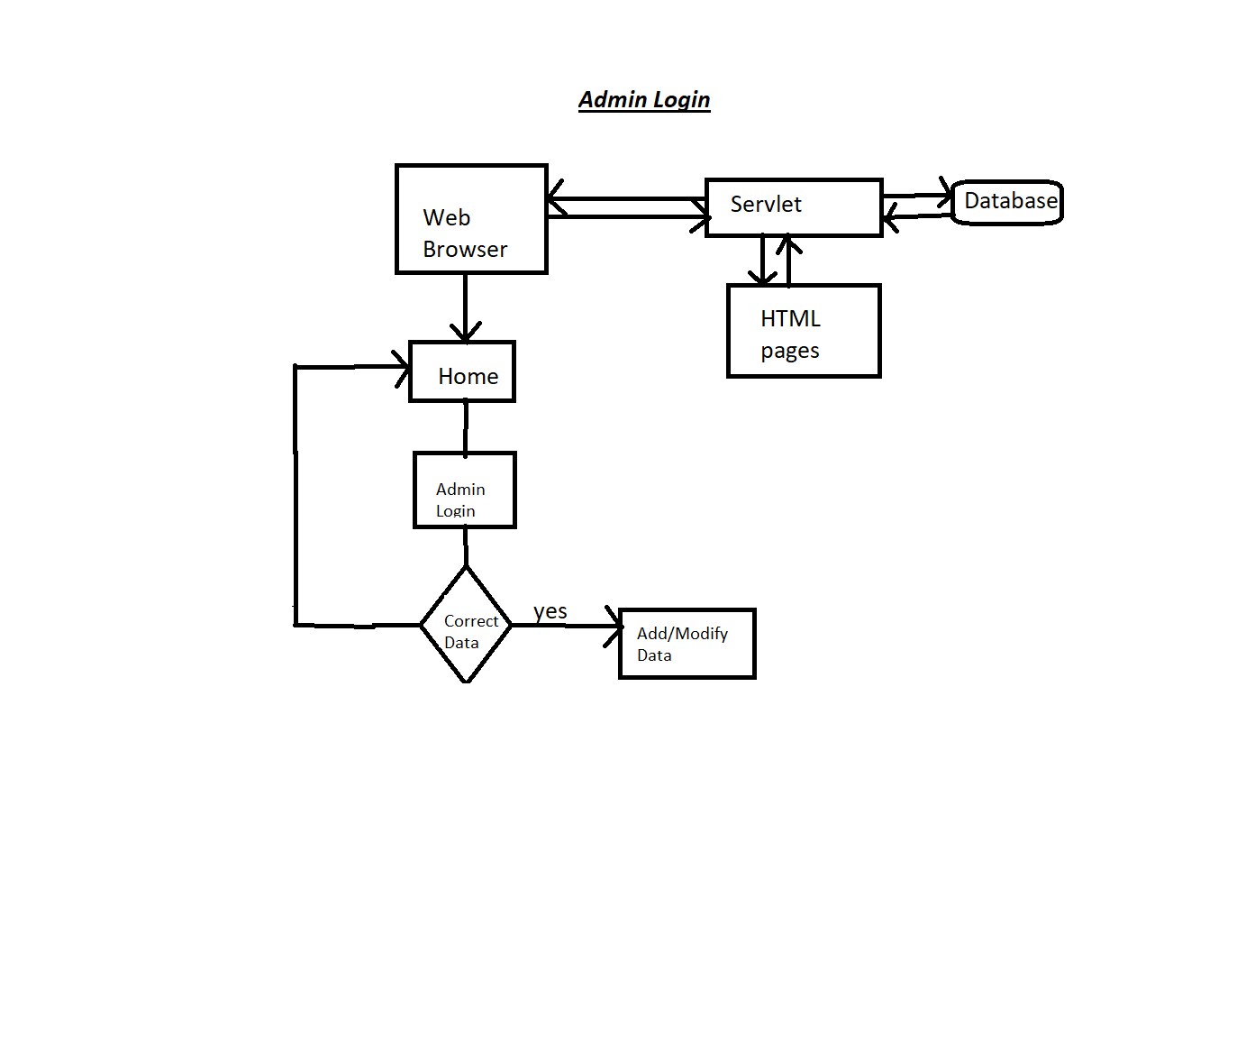**Architecture diagram / flow chart**

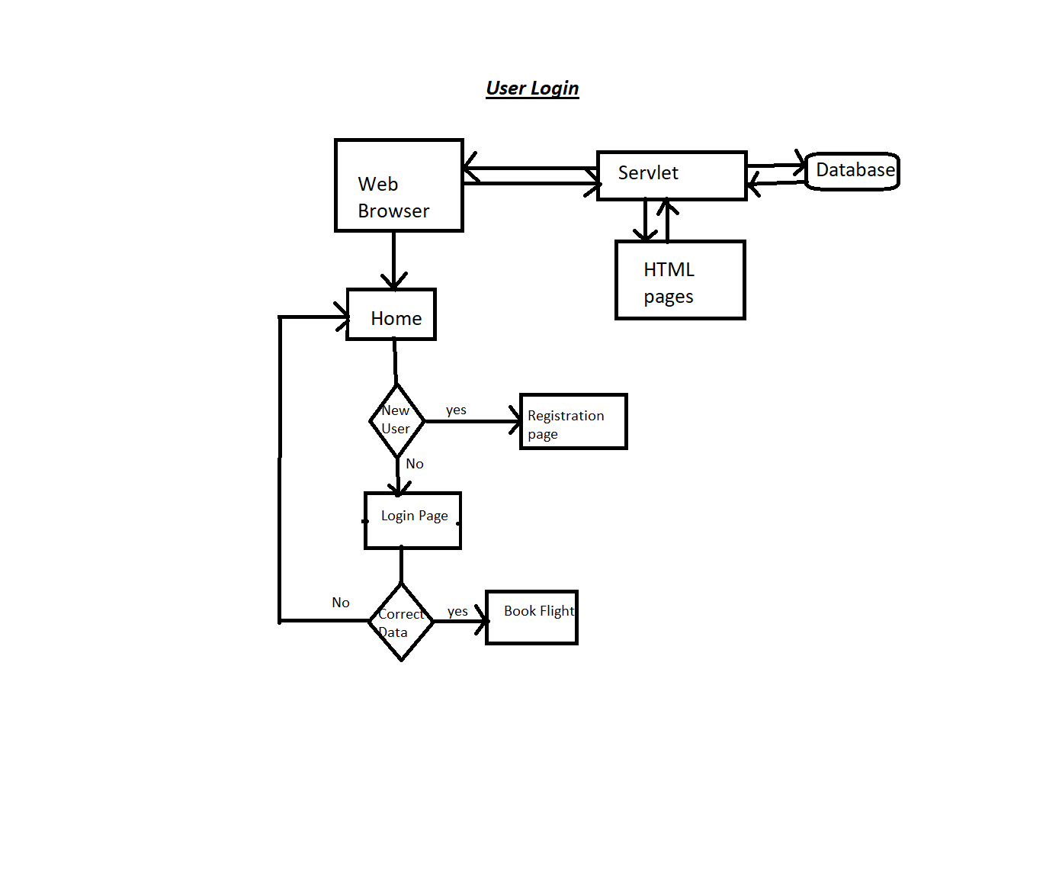

* 1. **Project Users Stories : ( Agile and Scrum )**

The project is planned to be completed in 3 sprints. Tasks assumed to be completed in the sprint are:

* Creating the flow of the application
* Initializing git repository to track changes as development progresses.
* Writing the Java program to fulfill the requirements of the project.
* Testing the Java program with different kinds of User input
* Pushing code to GitHub.

1) As an admin I can add or modified flight details.

2) As an admin I can observe the available flights.

3) As an admin I can observe source and destination location.

4) As an admin I can add/Increase ticket price.

5) As a user I can see the options of choosing my preferable airline.

6) As a user I want to see if there is a flight available in booking date.

7) As a user I want to pay my bills online.

8) AS a user I want to store my data.

The goal of the company is to deliver a high-end quality product as early as possible.

Sprint 1

1) As an admin I can add or modified flight details.

2) As an admin I can observe the available flights.

3) As an admin I can observe source and destination location.

4) As an admin I can add/Increase ticket price.

Sprint 2

5) As a user I can see the options of choosing my preferable airline.

6) As a user I want to see if there is a flight available in booking date.

Sprint 3

7) As a user I want to pay my bills online.

8) AS a user I want to store my data.

**3. Project git Repositories**

1. link : https://github.com/Atul105/Phase2-project

2. clone git : git clone git@github.com:Atul105/Phase2-project.git

**4. How to run poject:**

4.1. clone project

clone git : git clone https://github.com/Atul105/Phase2-project

4.2. open phase2-project

-> right click -> run on server -> select apache tomcatv8.0

**Directory Structure / package:**

## **Demonstrating the product capabilities, appearance, and user interactions**

To demonstrate the product capabilities, below are the sub-sections configured to highlight appearance and user interactions for the project:

Home page:

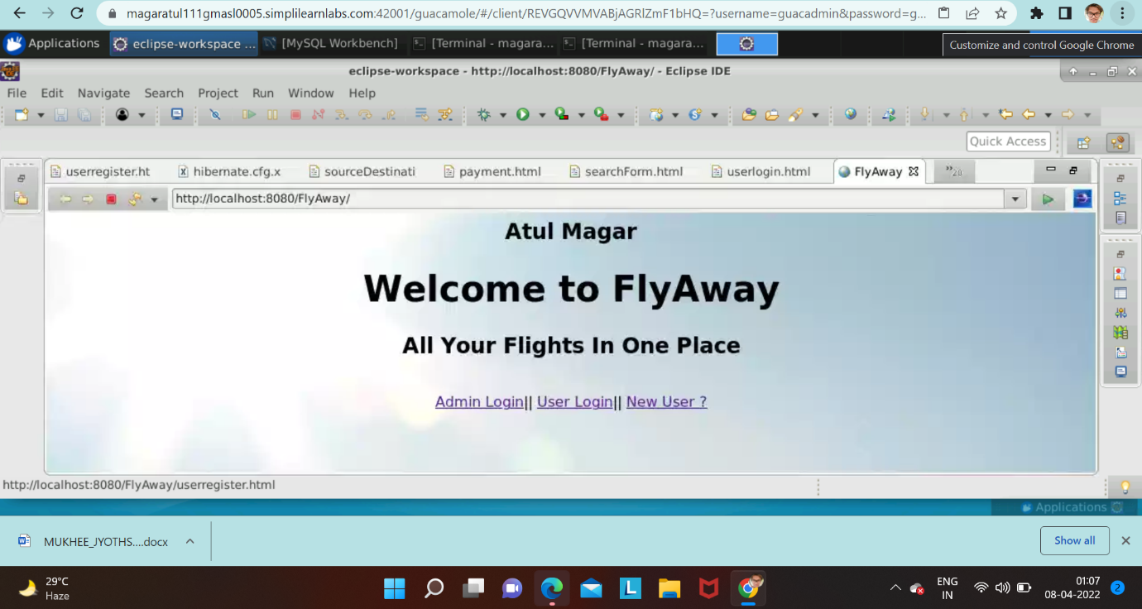

Admin Login:

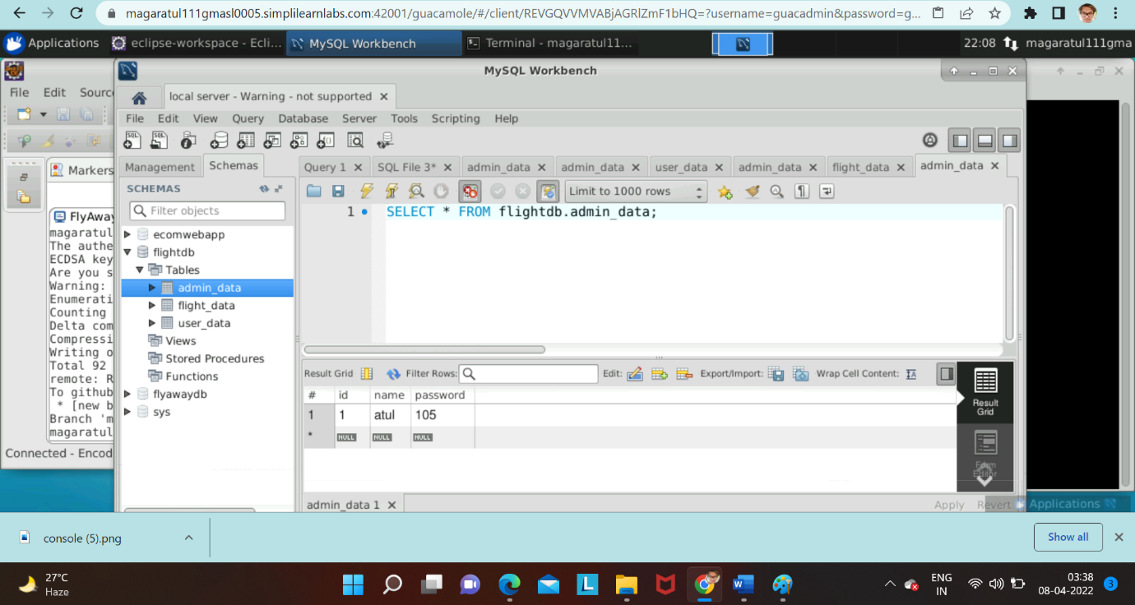

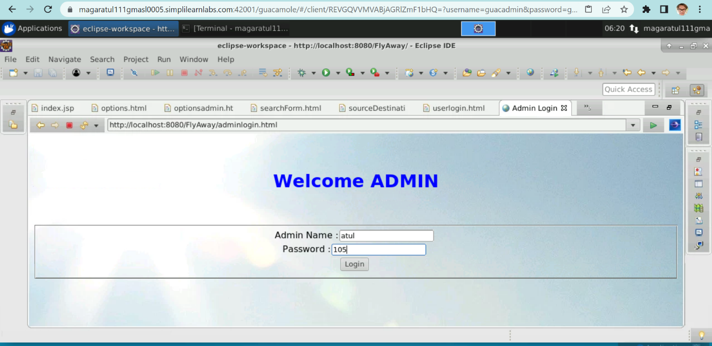

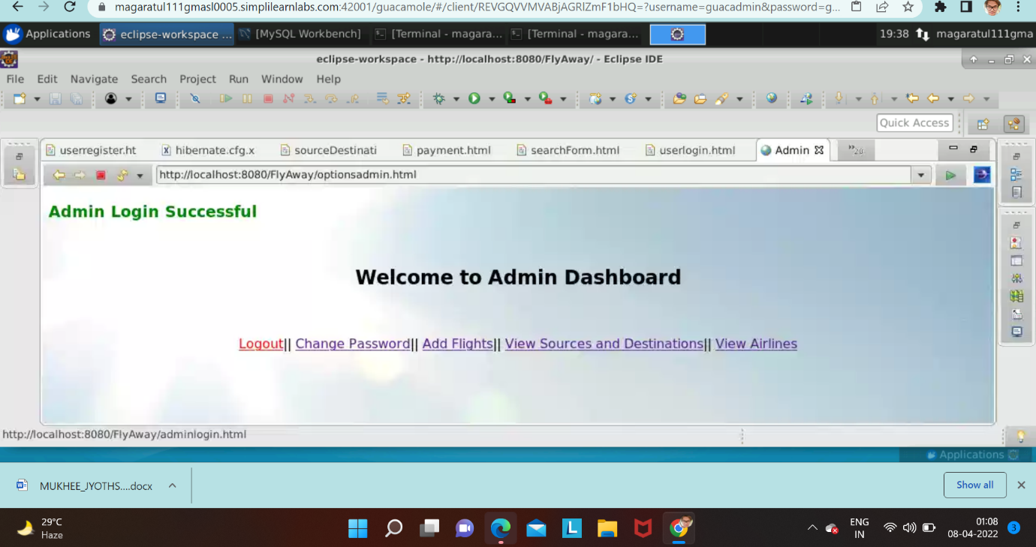

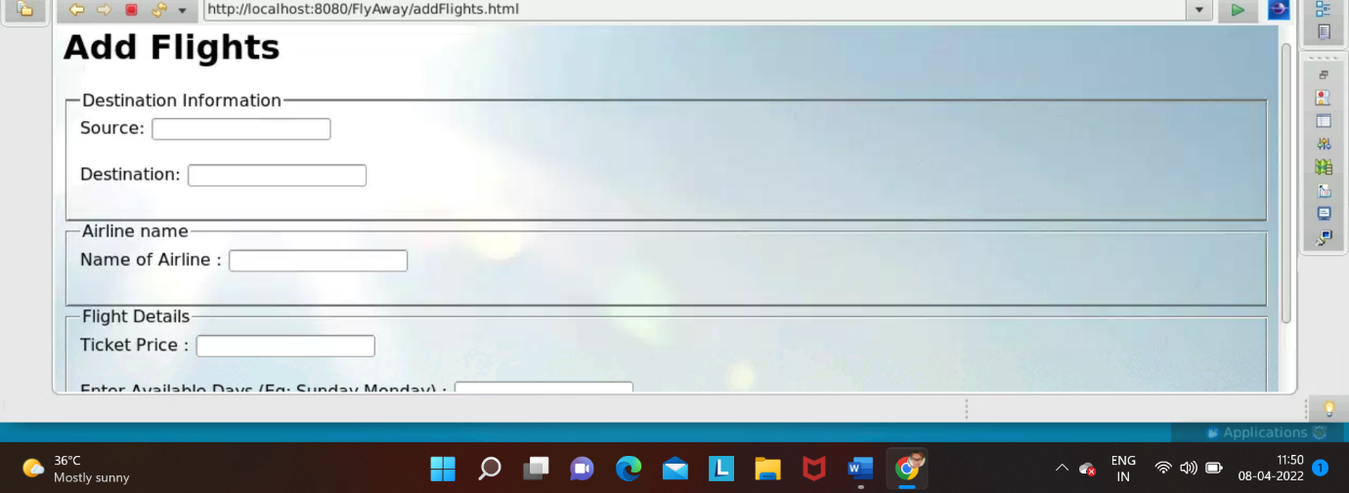

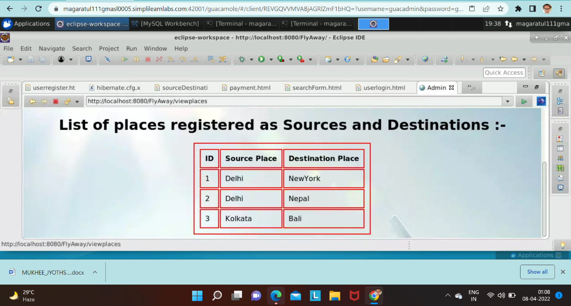

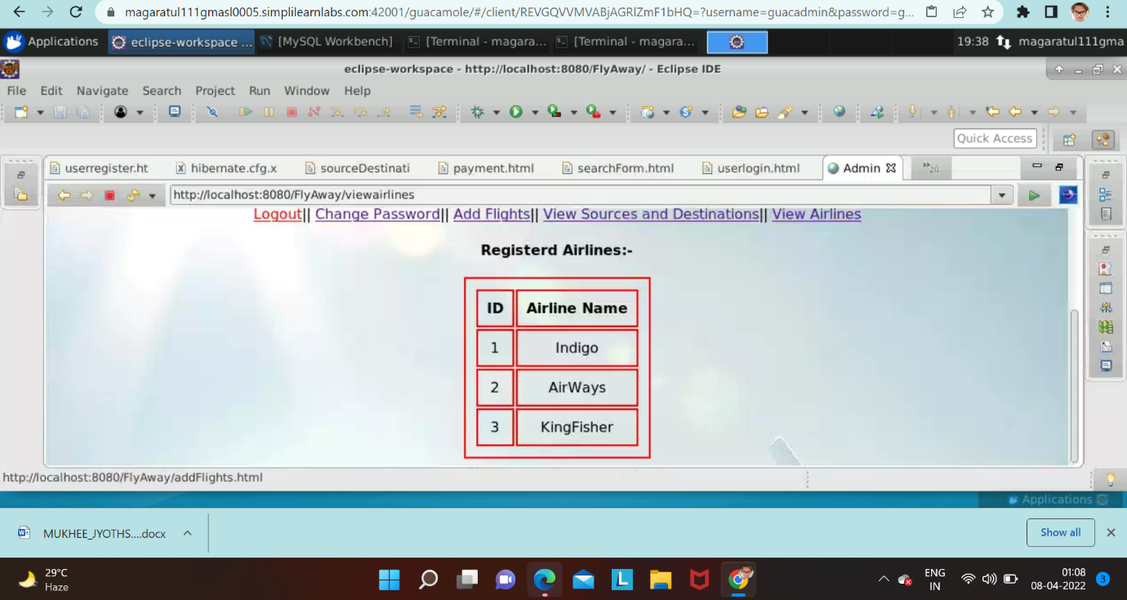

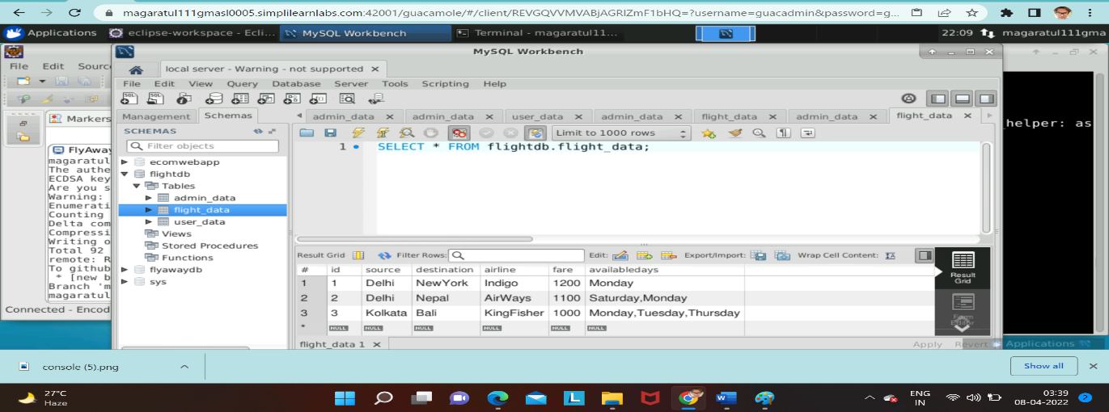

User Login:

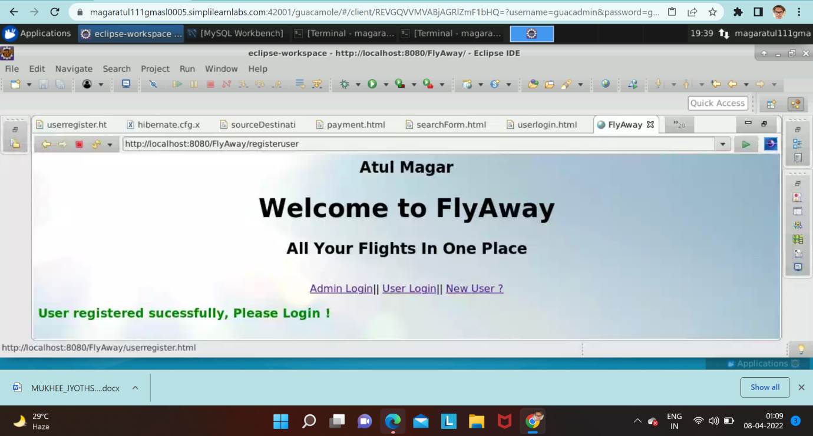

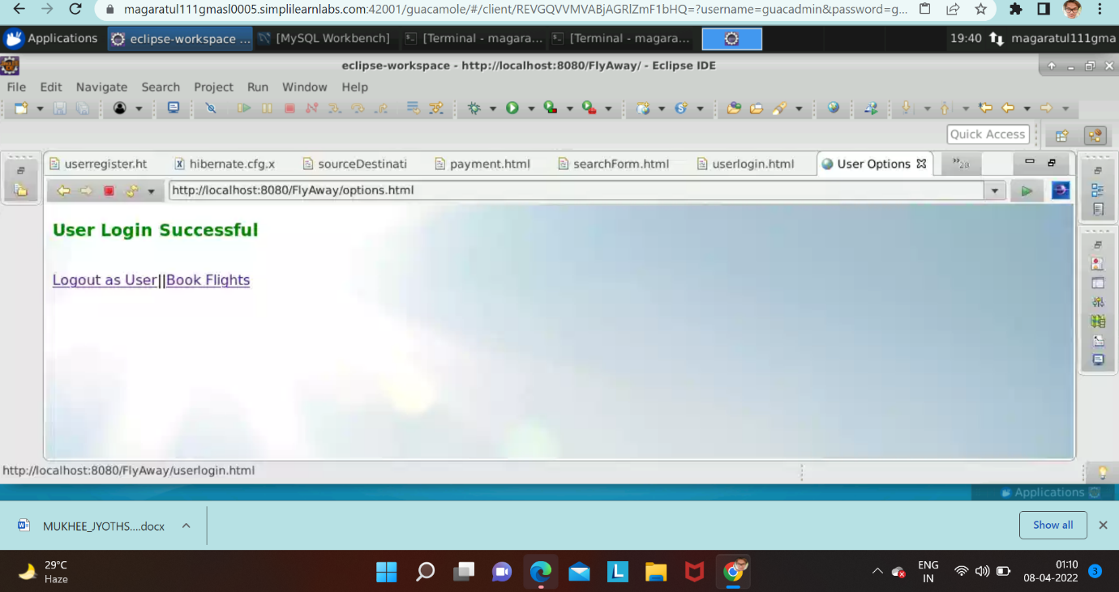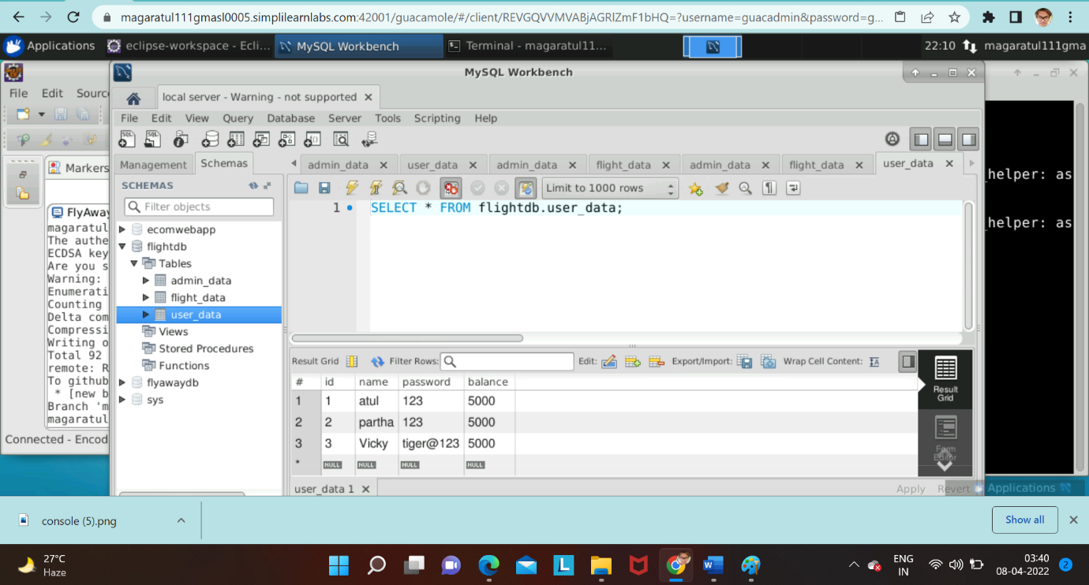

## 

## 

## 

## 

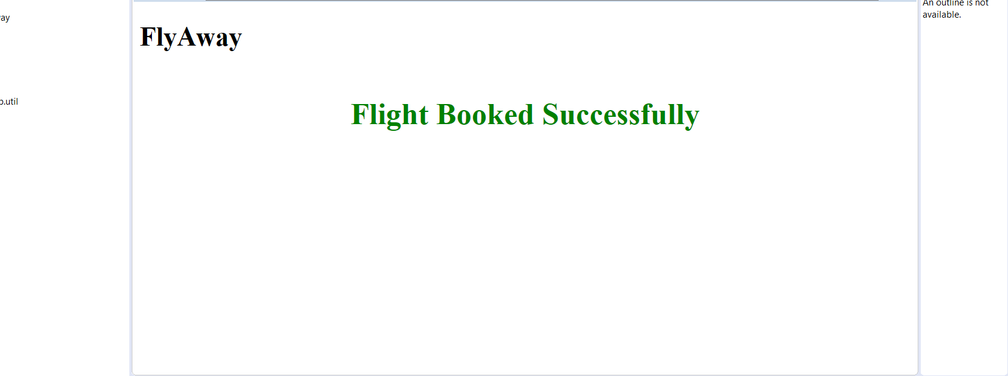

## Pushing the code to GitHub repository

* Open your command prompt and navigate to the folder where you have created your files.

*cd <folder path>*

* Initialize repository using the following command:

*git init*

* Add all the files to your git repository using the following command:

*git add .*

* Commit the changes using the following command:

*git commit . -m <commit message>*

* Push the files to the folder you initially created using the following command:

*git push -u origin master*

## **Conclusions**

In the program an application has been developed with a duration of three sprints. This application handle the data of the FlyAway AirWays. All the data about airlines are visible to user. The admin can login through a User ID and password and manipulated the data.